**Week 3 – Interactive Assignment**

**Countdown and Factorial**

Eric Vara

The University of Arizona Global Campus

CPT 200: Fundamentals of Programming Languages

Professor Amjad Alkilani

September 14, 2023

Here's the step-by-step explanation using your template for the number countdown and factorial calculation program:

##### Step 1: Identify Requirements

The primary goal was to craft an interactive program allowing a user to either view a countdown from a chosen number or calculate its factorial. This interaction should continue until the user wishes to exit. Appropriate feedback should be provided for any invalid input.

##### Step 2: Choosing Tools

The Python language was employed, utilizing its `input()` function to gather user responses and the `print()` function to display feedback and results. Loop constructs, like the `while` loop, facilitated repeated interactions. Decision-making was handled using `if`, `elif`, and `else` statements. To carry out operations, loops such as `for` were employed.

##### Step 3: Code Development

1. I initialized the program with a `while True:` loop to allow for continuous user interactions until they decide to terminate.
2. I used the `input()` function to solicit a number from the user, offering an option to exit by entering `-1`.
3. By utilizing an `if` statement, the program verifies if the number is positive.
4. After a valid number is entered, the user is provided with two primary operations through `input()`: countdown from the given number or compute its factorial. An additional option to exit the program (`3`) is presented.
5. Conditional checks (`if` and `elif` statements) determine the user's choice.
6. For the countdown, a `for` loop iterates from the provided number down to zero, displaying each iteration.
7. For the factorial, a `for` loop calculates the factorial of the given number.
8. If the user chooses an invalid operation, an error message is shown.
9. If a non-positive number is entered, an appropriate error message is relayed to the user.

##### Step 4: Testing

I executed the program with a variety of inputs to confirm its functionality. This involved:

* Providing valid numbers and selecting the countdown option to ensure the program correctly counts down.
* Giving valid numbers and opting for the factorial operation to verify the correct factorial value is computed.
* Entering negative numbers, zero, and non-numeric values to confirm the program responds with fitting error messages.
* Choosing to exit the program with both available exit options to guarantee a smooth termination.

And that wraps it up! That's the breakdown of the countdown and factorial calculation program in Python. This step-by-step narrative should offer clarity on the construction process.

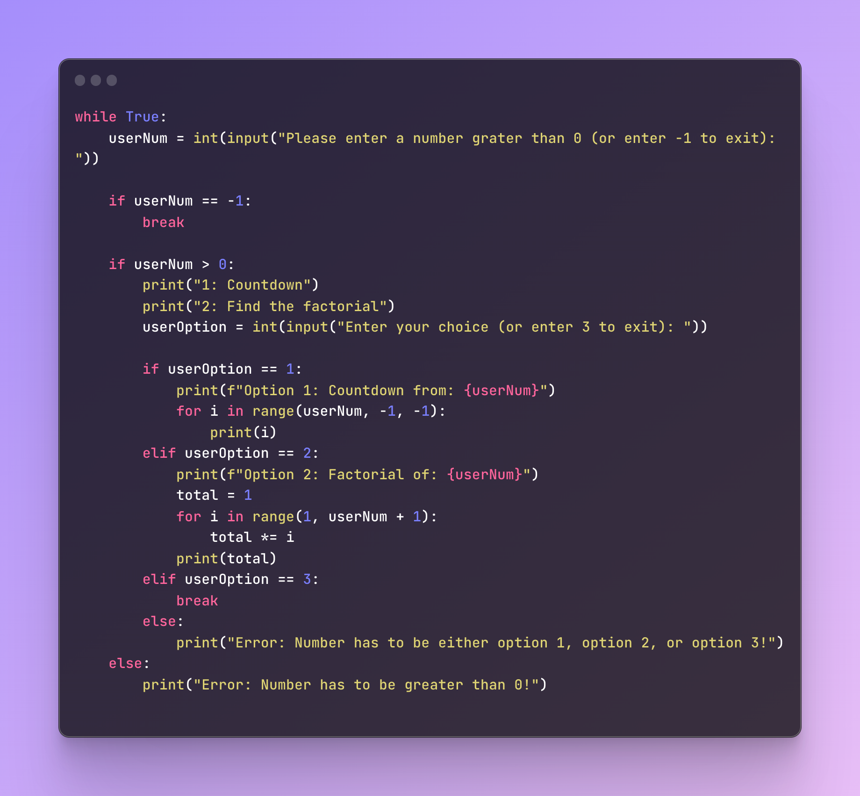

[Source Code](https://ray.so/#code=)

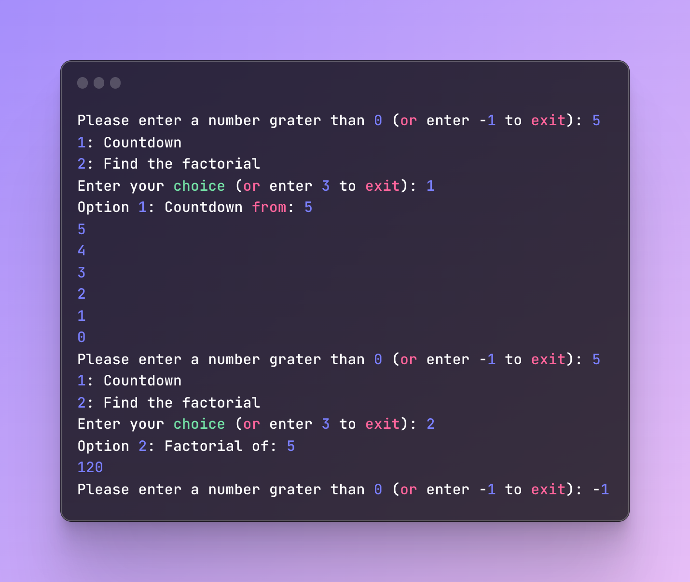

[Console](https://ray.so/#code=)